Cell REPRODUCTION (a STERNGRR process!)
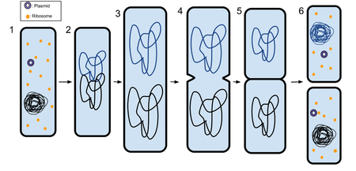

Prokaryotic cells:
Why do cells divide?

_____________
or “body” cells.
MITOSIS:

Eukaryotic cells:

Doubled
chromosome

The Cell Cycle

Mitosis
G₂
G₁
S

Mitosis:

46
___
___
Interphase:

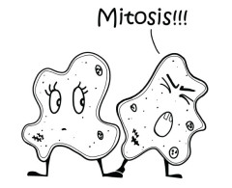
Uncontrolled cell division:

_________ ________ ________ ________ ________
REPRODUCTION (of organisms) depends on _________________ _____________________!

Asexual | Sexual
Parents ___________  Offspring __________________  Cell division _________________  12  TYPES of asexual reproduction:  1.  2.  3.  4.  5. | Parents ____________  46  Offspring __________________  Cell division _________________  MEIOSIS  Produces GAMETES  Fertilization:  Cons:  + =  Pros:  ______ _______ _______  (haploid) (haploid) (diploid)
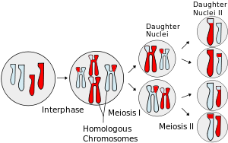
INDEPENDENT ASSORTMENT
Another source of genetic variation

Ex: What are the possible gametes that will be produced from this diploid cell?
___________________________________
MEIOSIS

