Organic Compounds, and Enzymes Name __________________________
REVIEW Date ______________ Period _______

- ORGANIC COMPOUNDS – Complete the following chart and answer the following questions.

Organic Compound | Building Block (Monomer, Subunit) | Function(s) | Common Food Sources
Carbohydrates

Lipids

Proteins |  | 1.  2.  3.  4.
Nucleic Acids |  |  | Nucleic Acids are not obtained by eating foods. Your DNA comes from your parents.

- Explain each of the following examples of CARBOHYDRATES:
- Starch:

- Cellulose:

- Glycogen:

- Chitin:

- Lab Review - For each organic compound, list how it was tested for in lab:
ORGANIC COMPOUND | HOW WAS IT TESTED FOR IN LAB?
Starchy Carbohydrates

Simple Sugar Carbohydrates

Lipids

Proteins

- Identify what organic compound each of these pictures are describing:

Picture | Organic Compound | Chemical Elements found in Each
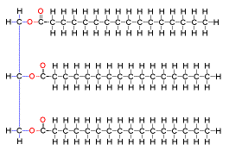
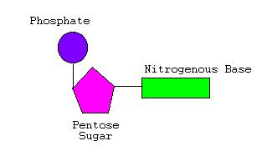
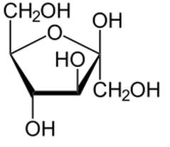
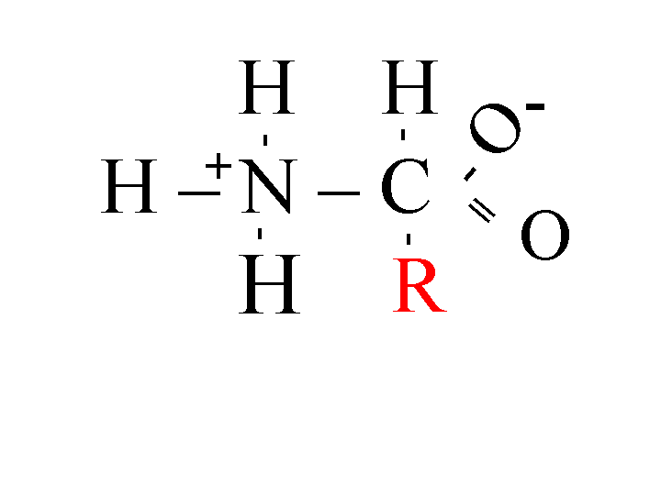

- If a molecule ends in –ose it is most likely a _____________________________.

- If a molecule ends in –ase it is most likely a _____________________________.

- What is the difference between a disaccharide and a polysaccharide?

- What is a dehydration synthesis reaction?

- What is a hydrolysis reaction?

- Differentiate between saturated fatty acids and unsaturated fatty acids.

- ENZYMES – Answer the following questions using your Enzyme notes.

- Describe the process of an enzyme acting on a substrate from beginning to end. Use all related vocabulary we have discussed. (enzyme, substrate, active site, enzyme-substrate complex, products)

.

- Why are enzymes necessary in living organisms?

Lower activation energy

- Analyze the following graph and answer the questions associated.

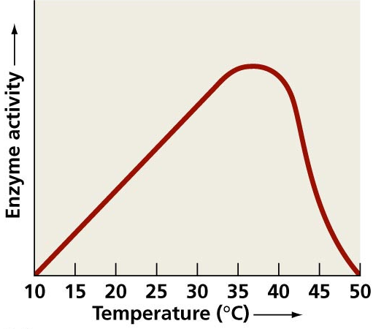
A.What temperature does this enzyme work best at?

B.What would happen to this enzyme if the temperature went up to
70°C?

C.What other factors can affect how well an enzyme functions and how do they affect an enzyme’s functioning?

- Analyze the following graph and answer the questions associated:
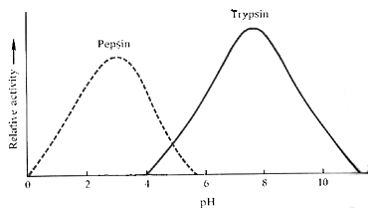
- Which enzyme functions best in an acidic environment?

- At a pH of 5, both enzymes are not working optimally. Explain.

- If the pH of the human stomach is approximately 4, which enzyme is probably most active there?

