Objective Sheet: Unit 1 (Part 1)
Tested Objectives

STERNGRR
Bio 2.1.2
- Analyze how various organisms accomplish life functions through adaptations within particular environments (example: water or land) to ensure survival and reproductive success.
- Relate prior understanding of survival and reproductive success to evidence of variations observed in species three areas:
- structural adaptations – nutrition, respiration, transport and excretion mechanisms,
- reproductive adaptations – sexual vs. asexual, eggs, seeds, spores, placental, types of fertilization (internal and external)

Classification
Bio.3.5.1
• Generalize the changing nature of classification based on new knowledge generated by research on evolutionary relationships and the history of classification system.
Bio.3.5.2
• Classify organisms using a dichotomous key.
• Compare organisms on a phylogenetic tree in terms of relatedness and time of appearance in geologic history.

Essential Vocabulary
Synthesis, transport, excretion, respiration, nutrition, growth/development, reproduction, regulation, homeostasis, Domain, kingdom, phylum, class, order, family, genus, species, taxa, binominal nomenclature, dichotomous key

Statements to Master
- Provide a simple description for each of the STERNGRR life processes.
- Identify the STERNGRR life process being described. (PowerPoint)
- Provide examples for each of the STERNGRR life processes.
- Explain the historical development of classification systems that moved from a 2 to 5 to 6 kingdom system of categorizing organisms
- Identify the 6 kingdoms of living organisms and provide examples of organisms in each
- Describe the 7 level (taxa) classification system for living organisms, including the progression from general to specific and the relationship of the levels to each other
- Compare the 7 taxa classification scheme of different organisms in order to determine which are most closely related
- Recognize an organism’s scientific name and identify that organism’s genus and species (Practice Problems)
- Use a dichotomous key to identify an organism (Practice Problems)

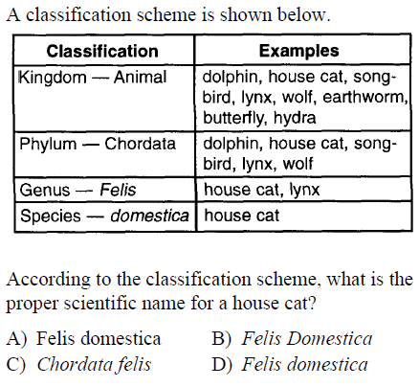
Practice Problem
